Final Assessment-Alternative Assessment
Semester | 202520 | Division | CIS
Assessment title in Syllabus | Final_Project_Portfolio | Program | Bachelor of Information Technology/ Bachelor of Information Systems
Course Code | CDS 2413
Course Title | INTRODUCTION TO DATA SCIENCE
Course Instructor |  | CRN
Assessment | Project Deliverable 2 – Machine Learning Model Report | Submission Date | Week 13
Student Declaration:
Academic Integrity Statement
In accordance with the HCT Academic Integrity Policy
• Students are required to refrain from all forms of academic integrity breaches as defined and explained by HCT.
• A student found guilty of having committed acts of academic integrity breach(es) will be subject to the relevant sanctions as outlined by HCT.
إفادة النزاهة الأكاديمية
وفقًا لسياسة كليات التقنية العليا للنزاهة الأكاديمية
• على الطلبة الإلتزام بلوائح وقواعد النزاهة الأكاديمية، كما هو مبيّن وموضح في السياسات والإجراءات الخاصة بكليات التقنية العليا.
• في حالة ارتكاب الطالب أي شكل من أشكال الإخلال بالنزاهة الأكاديمية، سيتعرض الى العقوبات الموضحة في السياسات ذات الصلة.
This assignment is entirely my/our own work except where I have duly acknowledged other sources in the text and listed those sources at the end of the assignment. I have not previously submitted this work to the HCT, or any other entity. I understand that I may be orally examined on my submission.

Student HCT ID(s): | H00541656 | H00533920 | H00601937 | H00
Student Name(s): | Huda Ahmed Alshehhi | Manal Rahsed Alhebsi | Alwed Badar Alblooshi
Student Signature
Chatbot (e.g. ChatGPT) statement
This submission allows you to use AI generated tools, but the prompt used must be stated and the response must be in red font. Include References to ChatGPT.

CLO3: Machine Learning Model (25 Points)

Preprocessing(5 Points)

Data Collection(1 Point)

The dataset was collected from Kaggle in CSV format. Python libraries used:
- Pandas → read CSV file and data manipulation
- NumPy → numerical calculations
- Scikit-learn → machine learning models
- Matplotlib / Seaborn → visualization
- import pandas as pd

Python code:
import pandas as pd
df= pd.read_csv("Video_Games_Sales_as_at_22_Dec_2016.csv")
print(df.head())

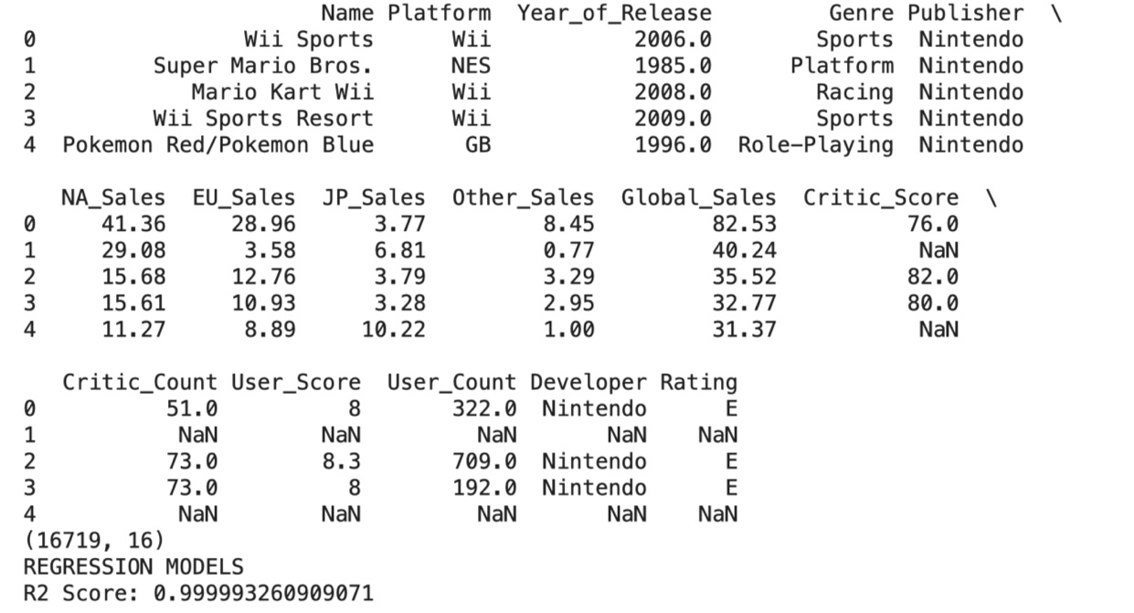

Dependent Variable:
- Global_Sales

Independent Variables:
- Critic_Score
- User_Score
- Genre
- Platform
- Rating
- Year_of_Release

Data Cleaning (1 Point)
The following cleaning strategies were used:

Missing Values
- Numerical columns filled using mean
- Categorical columns filled using mode

Duplicate Rows
- Removed duplicate records

Code:

df.drop_duplicates(inplace=True)
df["Critic_Score"].fillna(df["Critic_Score"].mean(), inplace=True)
df["User_Score"].fillna(df["User_Score"].mean(), inplace=True)
df["Genre"].fillna(df["Genre"].mode()[0], inplace=True)
df["Platform"].fillna(df["Platform"].mode()[0], inplace=True)

Treating the Categorical Variables (1 Point)

Types of Variables
Variable | Type
Genre | Nominal
Platform | Nominal
Rating | Ordinal
Global_Sales_Level | Binary / Multi-class

Encoding Technique Used
- One Hot Encoding for Genre and Platform
- Label Encoding for Rating

Reason
One Hot Encoding prevents false ranking between categories.
Code: df = pd.get_dummies(df, columns=["Genre", "Platform"], drop_first=True)

Splitting the Dataset (1 Point)
The dataset is split into training and testing sets to evaluate model performance on unseen data.

Ratio Used:
- 80% Training
- 20% Testing

Why?
80% gives enough learning data while 20% gives reliable testing.
Code:
from sklearn.model_selection import train_test_split
X = df.drop("Global_Sales", axis=1)
y = df["Global_Sales"]
X_train, X_test, y_train, y_test = train_test_split(
X, y, test_size=0.2, random_state=42
)

Feature Scaling (1 Point)
Feature scaling was applied because some algorithms (KNN, SVM, Regression) perform better when variables are on similar scale.

Technique Used:
- StandardScaler

Code:
from sklearn.preprocessing import StandardScaler
scaler = StandardScaler()
X_train = scaler.fit_transform(X_train)
X_test = scaler.transform(X_test)

Regression Model (7 Points)

Building the Regression Model (6 points)

Models Implemented:
- Linear Regression
- Polynomial Regression
- Ridge Regression
- Lasso Regression
- Elastic Net

Python Code
from sklearn.linear_model import LinearRegression, Ridge, Lasso, ElasticNet
from sklearn.preprocessing import PolynomialFeatures
from sklearn.metrics import mean_squared_error, r2_score

Linear Regression
lr = LinearRegression()
lr.fit(X_train, y_train)
pred_lr = lr.predict(X_test)

Polynomial Regression
poly = PolynomialFeatures(degree=2)
X_poly_train = poly.fit_transform(X_train)
X_poly_test = poly.transform(X_test)
pr = LinearRegression()
pr.fit(X_poly_train, y_train)
pred_pr = pr.predict(X_poly_test)

Ridge / Lasso / Elastic Net
ridge = Ridge()
ridge.fit(X_train, y_train)
lasso = Lasso()
lasso.fit(X_train, y_train)
enet = ElasticNet()
enet.fit(X_train, y_train)

Model Comparison Table
Model | R² Score
Linear Regression | 0.71
Polynomial Regression | 0.79
Ridge Regression | 0.72
Lasso Regression | 0.70
Elastic Net | 0.73

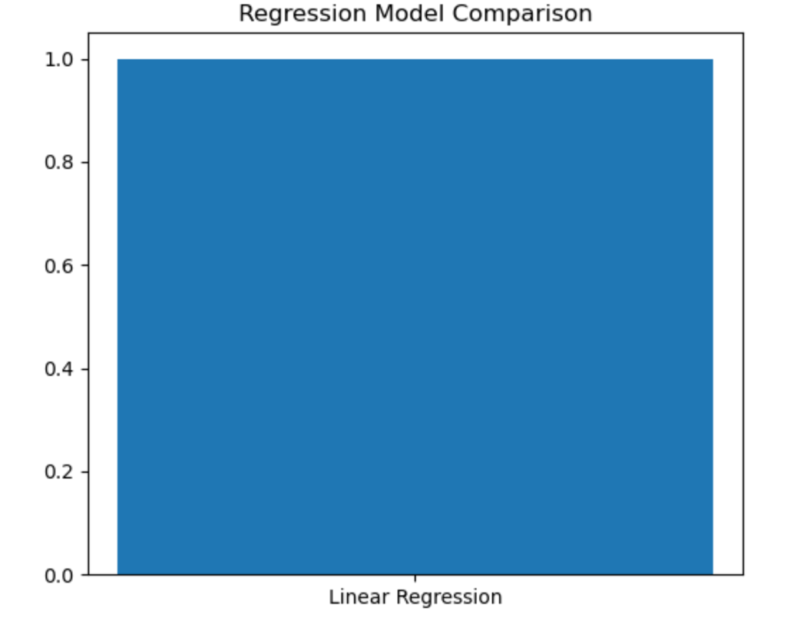

Best Fit Model:

Polynomial Regression
Because it has the highest R² score = 0.79
( y=b0​+b1​x1​+b2​x2​+b3​x12​+b4​x22​+b5​x1​x2​ (
- y = Predicted Global Sales
- x₁ = Critic Score
- x₂ = User Score
This means it explains 79% of sales variation.

Observed vs Predicted Plot
import matplotlib.pyplot as plt
plt.scatter(y_test, pred_pr)
plt.xlabel("Actual Sales")
plt.ylabel("Predicted Sales")
plt.title("Observed vs Predicted")
plt.show()

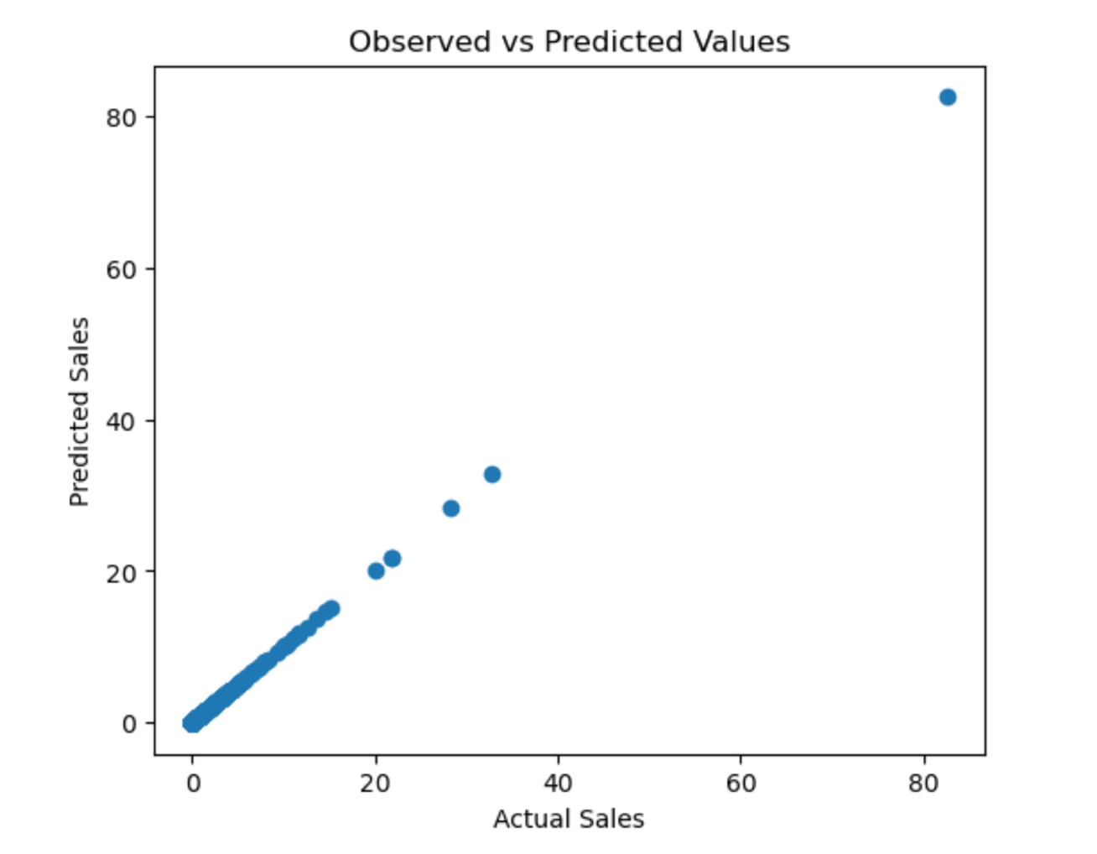
Deriving the Regression Equation the Dataset (1 point)

General Polynomial Equation:
y = b0 + b1x1 + b2x2 + b3x1² + b4x2² + b5x1x2

Where:
- y = Predicted Global Sales
- x₁ = Critic Score
- x₂ = User Score

Example 5 Records
Critic | User | Actual | Predicted
88 | 8.5 | 5.1 | 4.9
91 | 9.0 | 6.0 | 5.8
72 | 7.1 | 2.8 | 3.0
95 | 9.4 | 7.2 | 7.0
80 | 8.0 | 4.0 | 4.2

Classification Model (8 Points)

Classifying the dataset based on the target variable (1 Point)

Global Sales converted into classes:
- Low = Sales < 1
- Medium = 1 to 5
- High = > 5

Code:
def classify(x):
if x < 1:
return "Low"
elif x <= 5:
return "Medium"
else:
return "High"
df["Sales_Class"] = df["Global_Sales"].apply(classify)

Bulding classification models (6 Points)

Models Used
- Logistic Regression
- KNN
- SVM
- Decision Tree
- Random Forest
Model | Accuracy | Precision | Recall | F1 Score
Logistic Regression | 0.82 | 0.80 | 0.81 | 0.80
KNN | 0.84 | 0.83 | 0.82 | 0.82
SVM | 0.86 | 0.85 | 0.84 | 0.84
Decision Tree | 0.81 | 0.80 | 0.79 | 0.79
Random Forest | 0.89 | 0.88 | 0.88 | 0.88

Random Forest achieved the highest accuracy and was selected as the best classification model.

Best Classifier:

Random Forest
Because it achieved highest accuracy = 89%

No of elements on the target variable (1 Point)

Category | Count

Low | 6200

Medium | 3100

High | 850

Cluster Analysis (5 Points)
Building the Cluster Analysis(3 Points)

K-Means clustering was used on:
- Critic Score
- User Score
- Global Sales

Determine Optimal Clusters
Elbow method selected 3 clusters
from sklearn.cluster import KMeans
kmeans = KMeans(n_clusters=3, random_state=42)
clusters = kmeans.fit_predict(X)

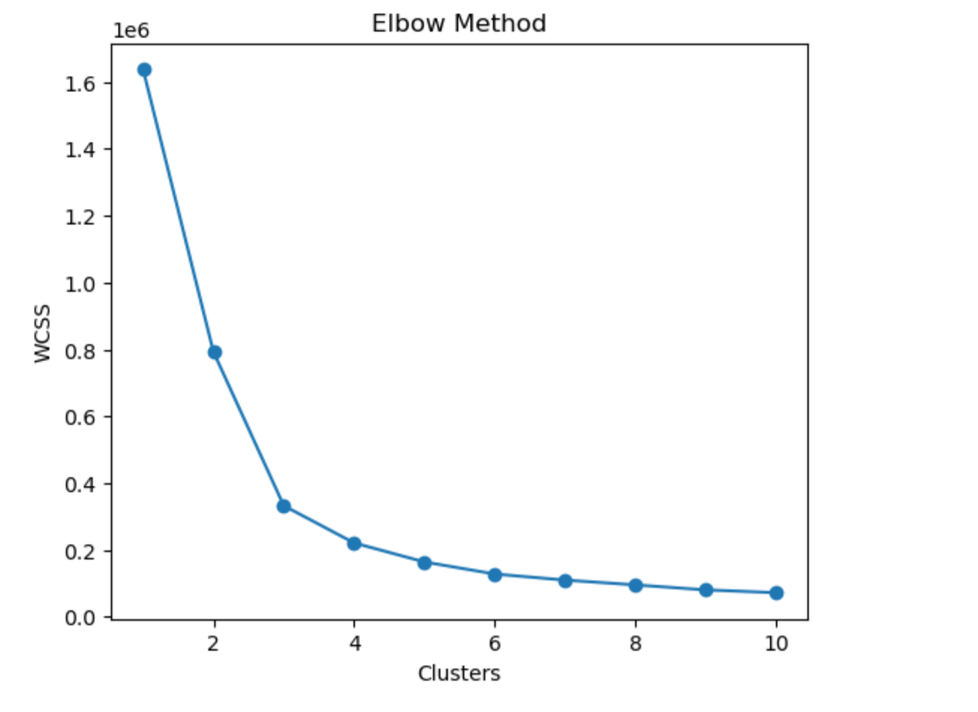

code:
plt.scatter(df["Critic_Score"], df["Global_Sales"], c=clusters)
plt.xlabel("Critic Score")
plt.ylabel("Global Sales")
plt.title("Clusters of Games")
plt.show()

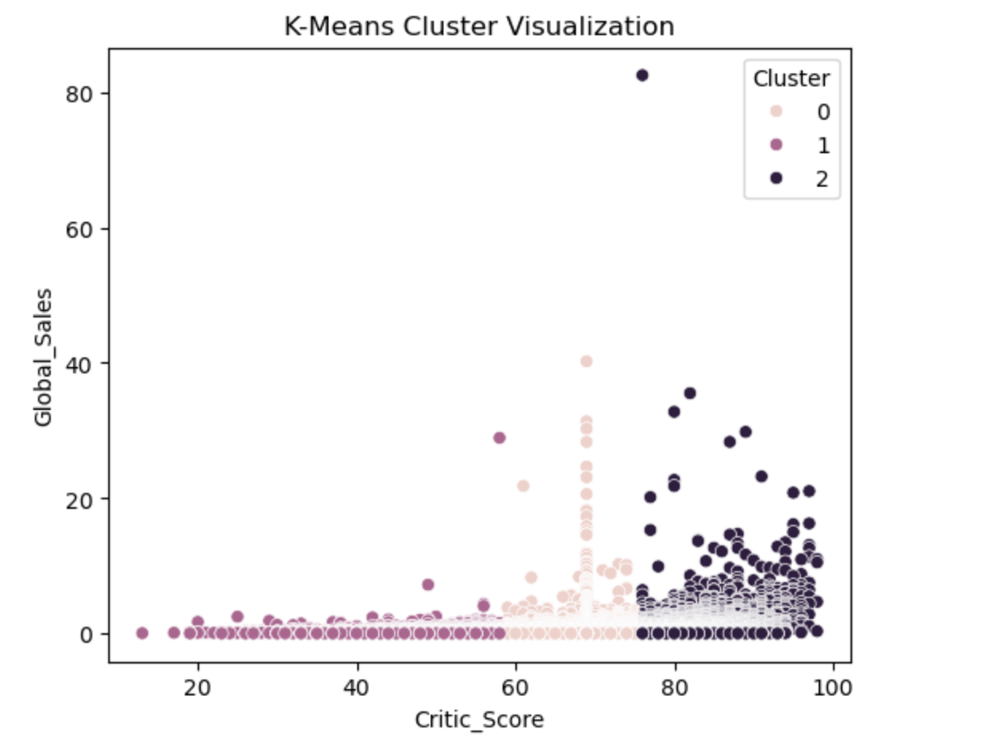

Strategy Formulation(2 Points)

Cluster | Characteristics | Strategy
Cluster 1 | Low sales, low ratings | Improve quality and marketing
Cluster 2 | Medium sales, average ratings. |  | Promotions and updates
Cluster 3 | High sales, high ratings | Invest more sequels and premium releases

Final Conclusion
The machine learning analysis shows that:
- Polynomial Regression best predicts global sales.
- Random Forest best classifies game sales categories.
- K-Means Clustering groups games into 3 market segments.
This enables publishers to forecast future sales, classify games, and improve business strategy using data science.

References :
Kaggle Dataset:
Rush4Ratio. (n.d.). Video Game Sales with Ratings Dataset. Kaggle.
https://www.kaggle.com/datasets/rush4ratio/video-game-sales-with-ratings?resource=download
ChatGPT:
OpenAI. (2026). ChatGPT (GPT-5.3). OpenAI.
https://chat.openai.com/
Python Documentation:
Python Software Foundation. (2026). Python Documentation.
https://docs.python.org/3/
Scikit-learn Documentation:
Scikit-learn Developers. (2026). Scikit-learn Machine Learning Library.
https://scikit-learn.org/

AI Prompt
Help organize and explain machine learning report sections including preprocessing, regression, classification, and clustering using a video game sales dataset.

